- Pick any one feature from a popular app you use (like Instagram's post upload, Zomato's order placement, or Flipkart's add to cart) and write 3 test cases you would re-test after a bug fix is made to that feature.
Ans=>
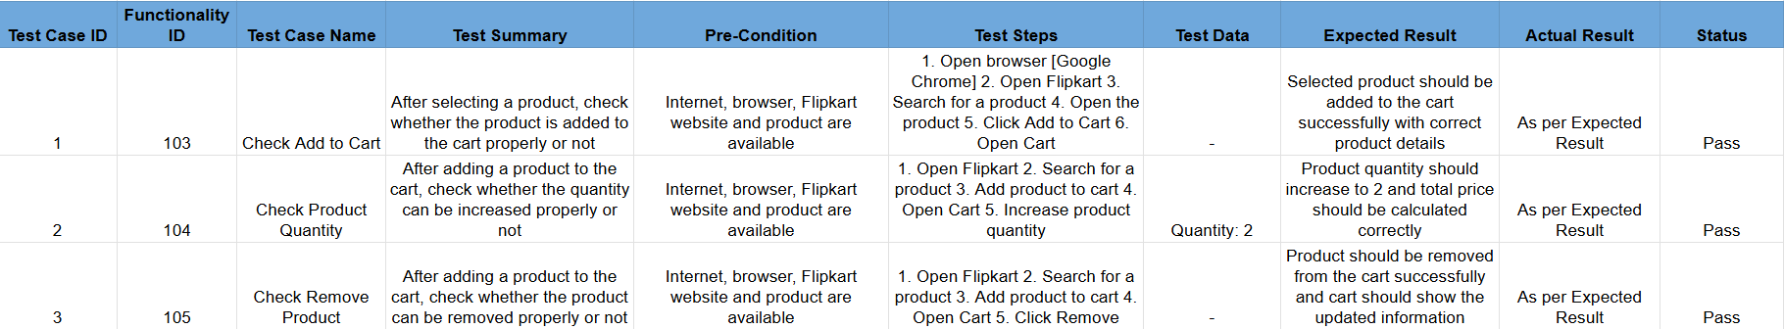

- Imagine you are testing the 'Apply Coupon' feature on Swiggy. After a bug related to coupon validation is fixed, design a re-testing checklist with at least 4 steps to confirm the fix works as expected.<br><br><em><strong>Hint:</strong> Think about both valid and invalid coupon scenarios.</em>
Ans=>
- Apply a valid, active coupon that meets all eligibility conditions and verify that the discount is applied correctly.
- Apply an invalid or expired coupon and verify that it is rejected with the appropriate validation message.
- Try a valid coupon when the minimum order value or other eligibility criteria are not met and confirm that the coupon is not applied.
- Apply a valid coupon multiple times or remove and reapply it to ensure the discount is calculated consistently and is not duplicated.

- Create a regression test suite for the 'Search' module in a music streaming app (like Spotify). List at least 5 regression test cases that should be run after any update to the search functionality.
Ans=>
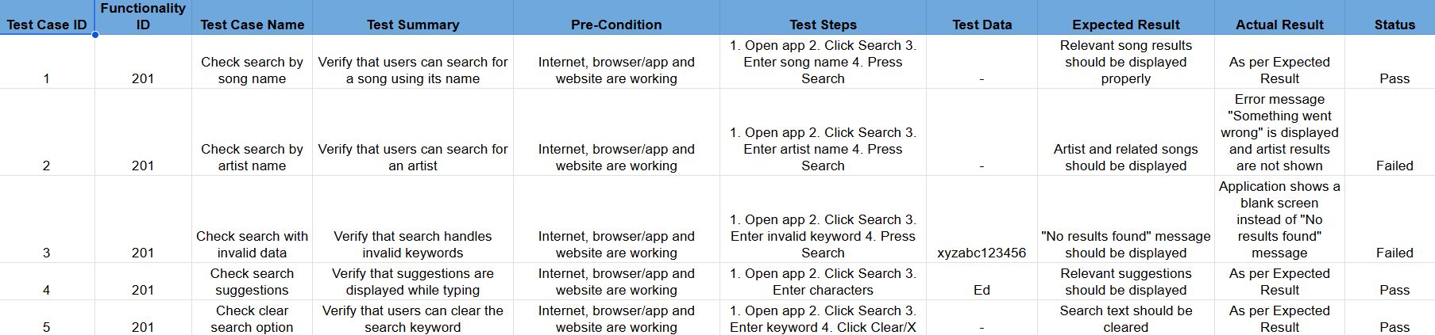

- Explain why regression testing is especially important in agile development when teams release new features every sprint. Give two examples from any app you use where skipping regression testing could cause old features to break.

Ans=> Regression testing is especially important in Agile development because teams release new features and updates frequently, often every sprint. A new change in one part of the application can accidentally affect an existing feature that was working correctly before.
It is important in Agile because:
- Frequent changes: New features are added every sprint, increasing the chance of defects.
- Existing functionality must remain stable: Regression testing checks that previously working features still work after an update.
- Early defect detection: Bugs can be found soon after a change instead of reaching the final release.
- Better user experience: Users should be able to use both new and existing features without problems.
Example 1 – Music Streaming App (Spotify-like):
Suppose developers add a new Search feature or improve the search algorithm. If regression testing is skipped, the update might accidentally break the Play button. Users may be able to search for songs but cannot play the selected song.

- Suppose your team just released a new version of a movie ticket booking app (like BookMyShow) with a major update to the payment module. Select 3 modules (other than payment) that could be affected and describe one regression test you would run for each.<br><br><em><strong>Hint:</strong> Think about modules like seat selection, booking history, or notifications that interact with payment.</em>
Ans=>
Module | Regression Test Case
1. Seat Selection | Select a movie, show time, and seats → proceed to payment → complete the booking.
2. Booking History | Complete a movie ticket booking successfully → open Booking History.
3. Notifications | Complete a successful ticket booking → check email/SMS/app notification.

